Eunhye Elementary School
331-27, Bulgwang-dong
Eunpyung-gu, Seoul, Korea
eunsunkim1004@gmail.com
010-6341-2004

December 12, 2016

To whom it may concern

Matt Hall has been a full time English teacher at Eunhye Elementary School since February 2015. During this period, he has been teaching a variety of classes designed for all levels of English.

He is a reliable hard-working teacher, who researches and creates excellent teaching materials and practices diverse teaching methods. He makes all his own teaching materials (games, worksheets, PowerPoint slides, activities, etc.) and shares these ideas with other teachers as well.

His lessons are well-organized. They demonstrate clear teaching points and include creative activities that grab and retain students’ attention. He is very adroit with applying relevant videos, songs, and other media to his lessons without compromising the grammatical and speaking goals he aims to teach. Students enjoy his classes and find him highly approachable outside of class.

Matt is a supportive coworker. He willingly helps his coworkers with any problems or questions they have, and he has proved a valuable addition to both the office and the school. I will miss him as I move on to a different school, but I wish him all the best for his future, and have no doubt he will be an asset for your school.

Sincerely Yours,
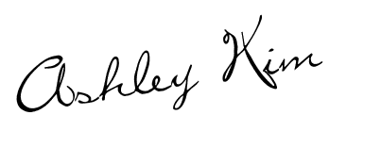

Ashley Kim
Head Teacher
Eunhye Elementary School

